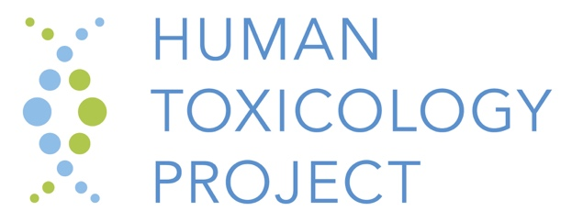

**AOP Hands-on Training: Building the Foundation for Predictive Toxicology**

**Wednesday, March 13, 4:30 PM–6:30 PM**

Hilton Baltimore, Paca Room  
401 West Pratt St, Baltimore, MD 21201

The Human Toxicology Project Consortium and the Physicians Committee for Responsible Medicine invite you to deepen your understanding of the Adverse Outcome Pathway framework. Following an introduction and overview of the OECD AOP framework and presentation of a real-life case study of AOP development and application, participants will be guided through an example of AOP-building in the AOP Wiki.

Please **bring a computer and register** in advance to [ksullivan@pcrm.org](mailto:ksullivan@pcrm.org). Registration is appreciated, but not required. Please indicate whether you will bring a laptop.

**Agenda:**

**4:30 – 5:30 Introductory presentations**

4:30 – 5:00: Introduction and overview of the OECD AOP framework

Catherine Willett, HTPC/Humane Society International

5:00 – 5:30: Approaches and tools for AOP assembly and an example of a Bayesian network approach to predicting steatosis

Natalia Reyero, Environmental Laboratory, Engineer Research & Development Center, US Army Corps of Engineers

5:30 – 5:40Application of the AOP framework to make regulatory decisions: Early case studies

Kristie Sullivan, PCRM

**5:40 – 6:30 AOP Wiki demonstration and hands-on activity**

* Finding AOPs and AOP info in the Wiki
* Entering information into the Wiki
* Adding a diagram

Kristie Sullivan, PCRM with support from Catherine and Natalia